
Year 7 Mathematics - Modified
Mini-Test 1

Numbers

Resource Section: one A4 page of notes

Name: _________________________
Time: 30 mins Class: ___________ / 30 marks

Full working out must be shown to get full marks. Attempt all the questions.

Question 1: Show using < and > which number is bigger. [6 marks]
- 9 ___ 10 | - -5 ___ 5
- -22 ___ -32 | - 0 ____ -4
- 3 ___ -2 | - -16 ___ -25

Question 2: Put the following from smallest to largest. [4 marks]

- -5, 4, -2, 7, 0, 8, -9, 3

Question 3: Solve the following. [6 marks]
- $5 + 7 =$ _____ | - $-6 + 2 = _____$
- $9 – 12 = ______$ | - $-12- -6 = _____$
- $-15 + -3 = ______$ | - $-3 + -2= _____$

Question 4: Solve the following using BIMDAS. [2, 2 = 4 marks]

- $5+4×3=$

- $15÷5+7=$

Question 6: Write whether these equations are TRUE or FALSE. [4 marks]
- $6+7=7+6$  ____________ | - $10-4=4-10$  ____________
- $\left(7-5\right)-3 =7-(5-3)$  ____________ | - $14÷2=2÷14$  ____________

Question 7: CIRCLE which of the following best describe: (5 + 4) + 6 = (6 + 4) + 5 [1 mark]
- $Commutative Law$ | - $Distributive Law$
- $Associative Law$ | - $These laws don^{'}tapply to subtraction$

Question 8: Circle which of the following is the best way to multiply 138 x 42 numbers. [1 marks]

140 x 40 (138 x 40) + (138 x 2)

Question 9: The temperature is -2°C. If the temperature rises by 15°C what is the new temperature?
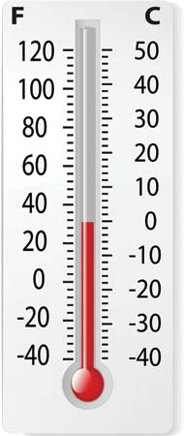
[2 marks]

Question 10: At midnight the temperature is - 6°C. At midday the temperature is 9°C. By how much has the temperature risen? [2 marks]

End of Test

